Spring security
Authorization and Authentication
Load User from the memory
Load user from the database
Custom Error page
Special topics

Authorization
It controls what user can control the appropriate or certain feature/API.
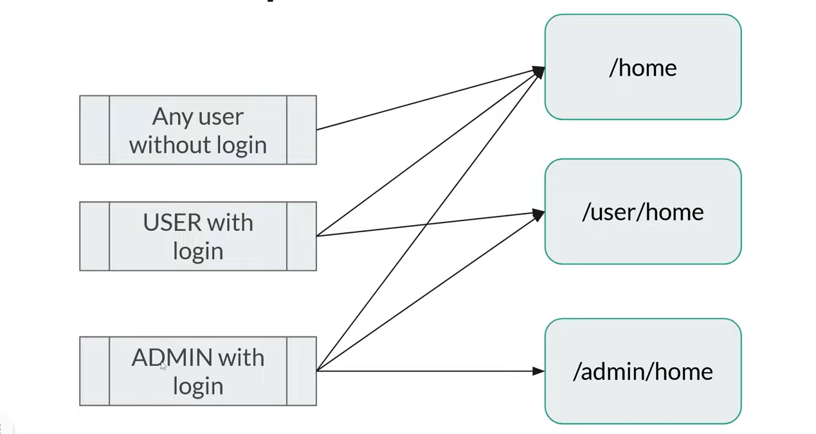

Step 1
Create Security Configuration

@Configuration
@EnableWebSecurity
public class AppSecurityConfiguration {
@Bean
public SecurityFilterChain securityfilterchan(HttpSecurity http) throws Exception
{
return http.authorizeHttpRequests(registry->
{
registry.requestMatchers("/home").permitAll();
registry.requestMatchers("/admin/**").hasRole("Admin");
registry.requestMatchers("/executive/**").hasRole("Executive");
registry.anyRequest().authenticated();

}).build();
}
}

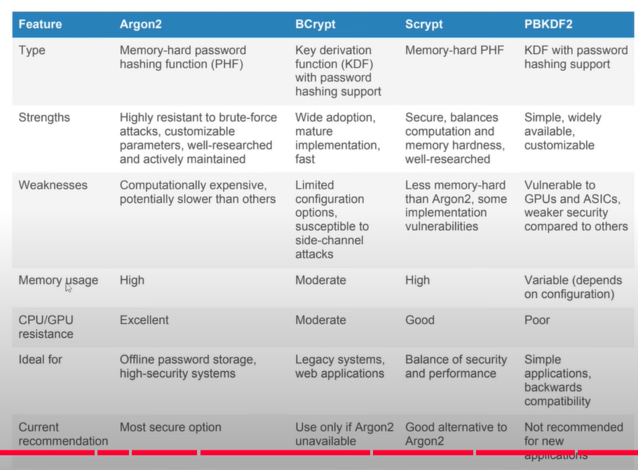

JWT – Json Web Token

Introduction of JWT

JSON Web Tokens (JWT) are a popular way to manage authentication and authorization for web applications

Header - Contains metadata about the token, such as the signing algorithm used
Payload - Contains the claims. Claims are statements about the user and additional data.
Signature - Ensures that the token hasn't been tampered with. It is created using the header, payload, a secret key, and the specified algorithm.

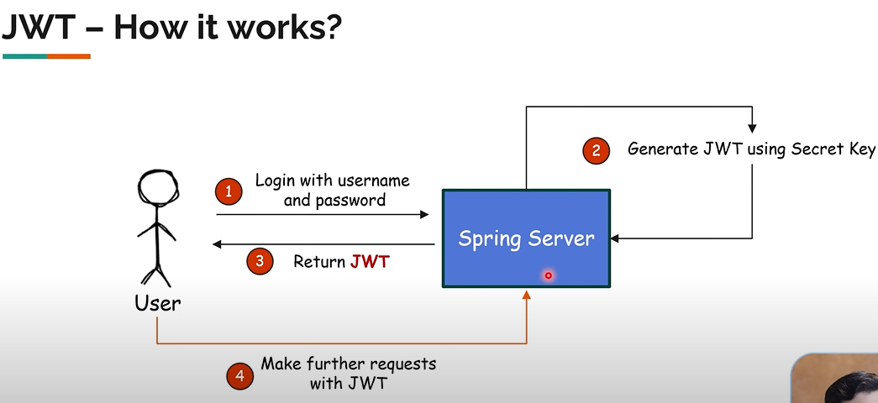

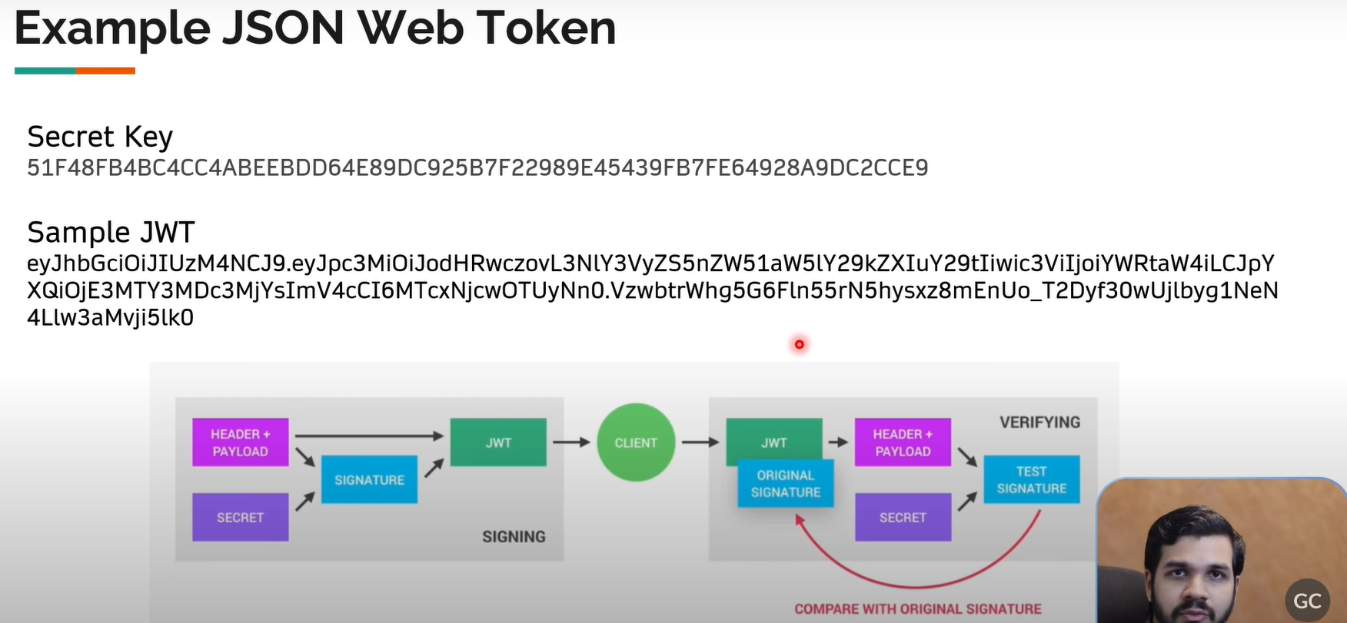

Familiarize and sample web project – refer GIT
Generate new JWT after authentication
When user try to log in with username and password first we have to validate uname and password and generate JWT

<!-- https://mvnrepository.com/artifact/io.jsonwebtoken/jjwt-api -->
<dependency>
<groupId>io.jsonwebtoken</groupId>
<artifactId>jjwt-api</artifactId>
<version>0.12.6</version>
</dependency>
<!-- https://mvnrepository.com/artifact/io.jsonwebtoken/jjwt-impl -->
<dependency>
<groupId>io.jsonwebtoken</groupId>
<artifactId>jjwt-impl</artifactId>
<version>0.12.6</version>
<scope>runtime</scope>
</dependency>
<!-- https://mvnrepository.com/artifact/io.jsonwebtoken/jjwt-jackson -->
<dependency>
<groupId>io.jsonwebtoken</groupId>
<artifactId>jjwt-jackson</artifactId>
<version>0.12.6</version>
<scope>runtime</scope>
</dependency>

Add above dependencies
Then, Create the service class for managing JWT operations

Authorize with JWT
Comparison of signing algorithm

